# LAB MANUAL # 08

# GRAPHIC USER INTERFACE Part II

## Objective:

The objective of this lab is to practice GUI in MATLAB using Guide.

## LAB TASK:

Design a GUI to display plot of sin and cos with following characteristics:

t = (0:0.001:1)

f = 5Hz

1. Use checkbox to select the plot type (sin or cos)
2. Change the amplitude of signal using radio button. Use four radio buttons to select amplitude having following values. (15, 20, 25, 30)
3. Use push button to plot the signal

Write your name and registration # on GUI and attach complete code with snapshots of all cases that show operations in running form in Lab Report.

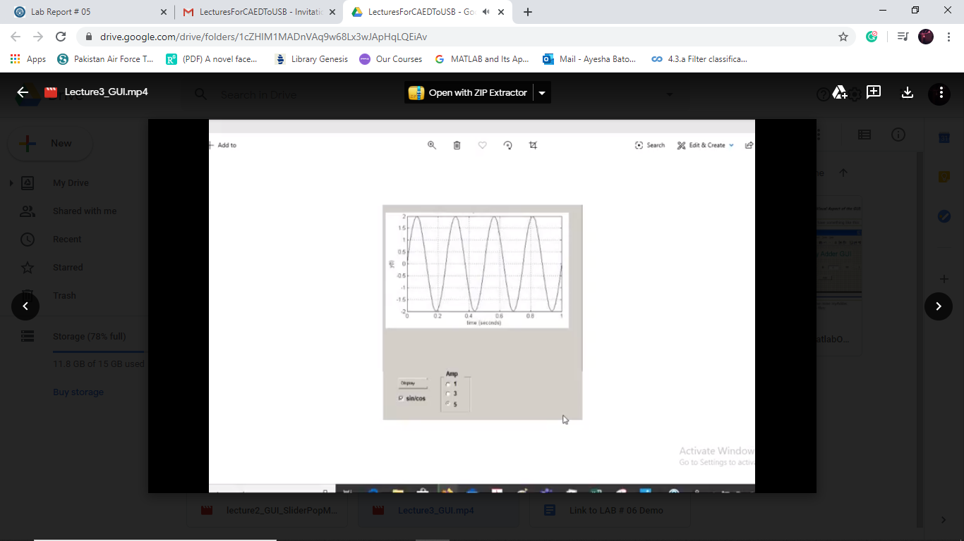

Figure 1: Sample GUI Design